BMS INSTITUTE OF TECHNOLOGY & MANAGEMENT

YELAHANKA, BENGALURU - 560064



**DEPARTMENT OF ARTIFICIAL INTELLIEGNCE AND MACHINE LEARNING**

**PROJECT BASED LEARNING**

2020-21 Even Semester

***“*AGENT OPTIMIZATION USING GENETIC ALGORITHM”**

*Submitted By*

***Student Name: Mrinal Durani*** *USN: 1BY19AI034*

***Student Name: Puja S.*** *USN: 1BY19AI040*

***Student Name: Rtwick George Moses*** *USN: 1BY19AI043*

***Student Name: Siddharth Arora*** *USN: 1BY19AI054*

***Under the guidance of***

*Dr. Anupama H S*

*Associate Professor of AI&ML*

***BMSIT&M***

***2020-21***

***EVEN Semester***

**INSTITUTE VISION**

To emerge as one of the finest technical institutions of higher learning, to develop engineering professionals who are technically competent, ethical and environment friendly for betterment of the society.

**INSTITUTE MISSION**

Accomplish stimulating learning environment through high quality academic instruction, innovation and industry-institute interface.

**DEPARTMENT VISION**

To develop professionals equipped to build sustainable and intelligent solutions that effectively interact with the natural intelligence towards creating a digitally empowered environment for future generations, safeguarding social ethics.

**DEPARTMENT MISSION**

* To enable students with the spirit and power of interdisciplinary acumen by integrating a world of knowledge into a world of intelligent systems and subsystems.
* Boost academic outcome through place-based education and collaborations with established research labs and industries.
* Encourage entrepreneurship efforts among students and develop them into great leaders.

|  |  |
| --- | --- |
| **Subject Name– Code - Course Outcomes (COs) w.r.t this PBL** | |
| CO # | CO DEFINED |
|  | ASK YOUR subject FACULTY ABOUT THIS |

|  |  |
| --- | --- |
| **Subject Name– Code - Course Outcomes (COs) w.r.t this PBL** | |
| CO # | CO DEFINED |
|  | ASK YOUR subject FACULTY ABOUT THIS |

|  |  |
| --- | --- |
| **Subject Name– Code - Course Outcomes (COs) w.r.t this PBL** | |
| CO # | CO DEFINED |
|  | ASK YOUR subject FACULTY ABOUT THIS |

|  |  |
| --- | --- |
| **Subject Name– Code - Course Outcomes (COs) w.r.t this PBL** | |
| CO # | CO DEFINED |
|  | ASK YOUR subject FACULTY ABOUT THIS |

|  |  |
| --- | --- |
| **Subject Name– Code - Course Outcomes (COs) w.r.t this PBL** | |
| CO # | CO DEFINED |
|  | ASK YOUR subject FACULTY ABOUT THIS |

**Project to Program Outcomes (PO) Mapping**

**Project Name:** title (ASK YOUR subject FACULTY ABOUT THIS)

|  |  |  |  |  |  |  |  |  |  |  |  |  |
| --- | --- | --- | --- | --- | --- | --- | --- | --- | --- | --- | --- | --- |
| **COURSE** | **PO1** | **PO2** | **PO3** | **PO4** | **PO5** | **PO6** | **PO7** | **PO8** | **PO9** | **PO10** | **PO11** | **PO12** |
| Subject Name |  |  |  |  |  |  |  |  |  |  |  |  |
| Subject Name |  |  |  |  |  |  |  |  |  |  |  |  |
| Subject Name |  |  |  |  |  |  |  |  |  |  |  |  |
| Subject Name |  |  |  |  |  |  |  |  |  |  |  |  |
| Subject Name |  |  |  |  |  |  |  |  |  |  |  |  |

|  |  |
| --- | --- |
| **Program outcomes (POs):** | |
| **PO1** | **Engineering knowledge:** Apply the knowledge of Mathematics, Science, Engineering fundamentals and an engineering specialization to the solution of complex engineering problems |
| **PO2** | **Problem analysis:** Identify, formulate, review research literature, and analyse complex Engineering problems reaching substantiated conclusions using first principles of mathematics, Natural sciences and engineering sciences |
| **PO3** | **Design/development of solutions:** Design solutions for complex engineering problems and design system components or processes that meet the specified needs with appropriate consideration for the public health and safety, and the cultural, societal, and environmental considerations. |
| **PO4** | **Conduct investigations of complex problems**: Use research-based knowledge and research methods including design of experiments, analysis and interpretation of data, and synthesis of the Information to provide valid conclusions |
| **PO5** | **Modern tool usage**: Create, select, and apply appropriate techniques, resources, and modern Engineering and IT tools including prediction and modelling to complex engineering activities with an understanding of the limitations. |
| **PO6** | **The engineer and society:** Apply reasoning informed by the contextual knowledge to assess societal, health, safety, legal and cultural issues and the consequent responsibilities relevant to the professional engineering practice. |
| **PO7** | **Environment and sustainability:** Understand the impact of the professional engineering solutions in societal and environmental contexts, and demonstrate the knowledge of, and need for Sustainable development |
| **PO8** | **Ethics:** Apply ethical principles and commit to professional ethics and responsibilities and norms of the engineering practice. |
| **PO9** | **Individual and team work:** Function effectively as an individual, and as a member or leader in diverse teams, and in multidisciplinary settings |
| **PO10** | **Communication:** Communicate effectively on complex engineering activities with the engineering Community and with society at large, such as, being able to comprehend and write effective reports And design documentation, make effective presentations, and give and receive clear instructions. |
| **PO11** | **Project management and finance:** Demonstrate knowledge and understanding of the Engineering and management principles and apply these to one’s own work, as a member and Leader in a team, to manage projects and in multidisciplinary environments. |
| **PO12** | **Life-long learning:** Recognize the need for, and have the preparation and ability to engage in independent and life-long learning in the broadest context of technological change. |

**ABSTRACT**

The objective of this project is to create a dynamic system to improve agents in a given environment to perform a certain set of tasks using the genetic algorithm approach to optimize the neural networks to find suitable architecture and optimal agents. This Program is constructed where we train a Neural Network for it to play Flappy Bird the Game. It’s inspired by the natural processes that drive biological evolution and although it sounds complicated, the principles behind it are actually quite simple.

**INTRODUCTION**

A neural network is a series of algorithms that endeavors to recognize underlying relationships in a set of data through a process that mimics the way the human brain operates. In this sense, neural networks refer to systems of neurons, either organic or artificial in nature. Neural networks can adapt to changing input; so, the network generates the best possible result without needing to redesign the output criteria. The concept of neural networks, which has its roots in artificial intelligence, is swiftly gaining popularity in the development of trading systems. A neural network evaluates unearths opportunities for making trade decisions based on the data analysis. The networks can distinguish subtle nonlinear interdependencies and patterns other methods of technical analysis cannot.

Genetic algorithms are stochastic search algorithms which act on a population of possible solutions. They are loosely based on the mechanics of population genetics and selection. They are probabilistic search methods; this means that the states which they explore are not determined solely by the properties of the problems. A random process helps to guide the search. Genetic algorithms are used in artificial intelligence like other search algorithms are used in artificial intelligence — to search a space of potential solutions to find one which solves the problem.

**MOTIVATION**

AI and Machine Learning has arrived. It’s driving cars, powering chatbots, beating humans at board games and investing in the stock market. It used to be just for experts and big tech companies. But now regular developers like us can use cloud services from Microsoft and Google or machine intelligence libraries like TensorFlow. Now that AI and ML is going mainstream, we realized it’s time for us to see what it’s all about. What better way to learn than making an AI to play Flappy Bird a game we all have grown up with.

**EXISTING SYSTEMS**

Gamification is the application of game-design elements and game principles in non-game contexts And In 1987 the first published research appeared which used the Genetic Algorithm as a means of seeking better strategies in playing the repeated Prisoner's Dilemma. Since then, the application of Genetic Algorithms to game-theoretical models has been used in many ways. In its current form it is used in the form of neural networks to simulate agents in controlled environments where the winners are the propagated with crossover taking place to produce the next set of agents.

Current systems use neural networks or other means to create agents to play various systems or games like the stock market and may or may not  have a dynamic architecture and some scenarios which relies on multi-tasking scenarios where it is NP in nature may also exploit the genetic system.

Further more dynamic systems which have the issue of uncertainty like war games also exploit it and can be successfully navigated by simulating using the genetic approach.

**LIMITATIONS IN EXISTING SYSTEMS**

A major issue which occurs when designing agents is the issue of designing the neural network architecture as foundation of the the agents the issues is whether to keep it static where it gets trained and evolves this is the most commonly used method for most systems because a simple DNN can be used to and noticeable progress is seen.

If a dynamic system is when we have multiple architectures and they are all trained and the best of the architectures are selected and you can be sure that the most optimal solution is arrived upon but is much more computationally expensive.

**PROPOSED SYSTEM**

Initialization phase: here the system randomly creates agents for specific architectures.

Training phase: this phase takes the agents and architectures and agents and trains each individual architecture a set number of times.

Evaluation phase: here each architecture is sorted based on the rate of improvement after the training phase and is then given the next number of times is is allowed to train for example the most improved will be given the ability to train 10 times the next 5 and so on and so forth.

The control loop: this decides when the the max number of training cycles are done and exits both the training phase and evaluation phase to give us the final agent which is most optimal for the environment

**PROPOSED METHODOLOGY**

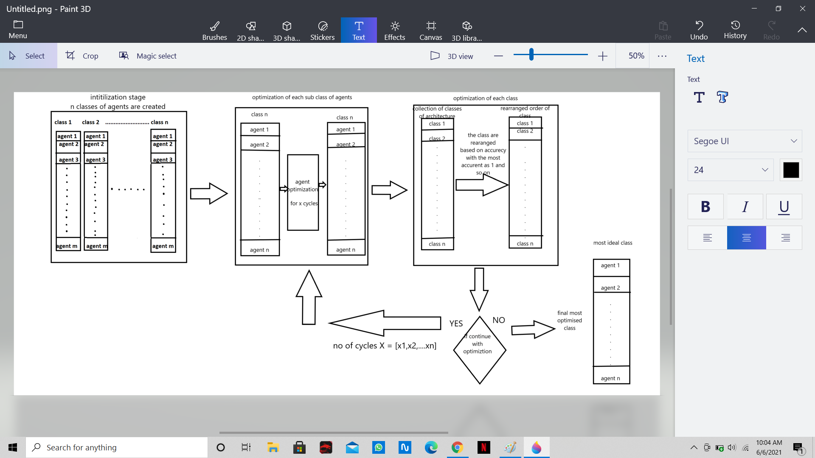

**REFERENCES**

1. [Deep reinforcement learning using genetic algorithm for parameter optimization](https://ieeexplore.ieee.org/abstract/document/8675632) - - IEEE (Feb 2019)

https://ieeexplore.ieee.org/abstract/document/8675632

1. [Scalability and optimisation of a committee of agents using genetic algorithm](https://ieeexplore.ieee.org/abstract/document/8675632) - - EEE Dept Imperial College London (May 2007)

https://arxiv.org/pdf/0705.1757.pdf

1. [Genetic algorithm optimisation of an agent-based model for simulating a retail market](https://www.researchgate.net/publication/23541636_Genetic_Algorithm_Optimisation_of_An_Agent-Based_Model_for_Simulating_a_Retail_Market) - - AJ Heppenstall (University of Leeds) (Dec 2007)

https://www.researchgate.net/publication/23541636_Genetic_Algorithm_Optimisation_of_An_Agent-Based_Model_for_Simulating_a_Retail_Market

1. [UAV cooperative multiple task assignments using genetic algorithms](https://ieeexplore.ieee.org/abstract/document/1470429)

- IEEE (June 2005)

https://ieeexplore.ieee.org/abstract/document/1470429

1. [Playing games with genetic algorithms](https://www.researchgate.net/publication/228697986_Playing_Games_with_Genetic_Algorithms)

- Robert Marks (Jan 2002)

https://www.researchgate.net/publication/228697986_Playing_Games_with_Genetic_Algorithms

1. [Generating war game strategies using a genetic algorithm](https://www.researchgate.net/publication/3949330_Generating_war_game_strategies_using_a_genetic_algorithm)

- Robert McCartney (Feb 2002)

https://www.researchgate.net/publication/3949330_Generating_war_game_strategies_using_a_genetic_algorithm